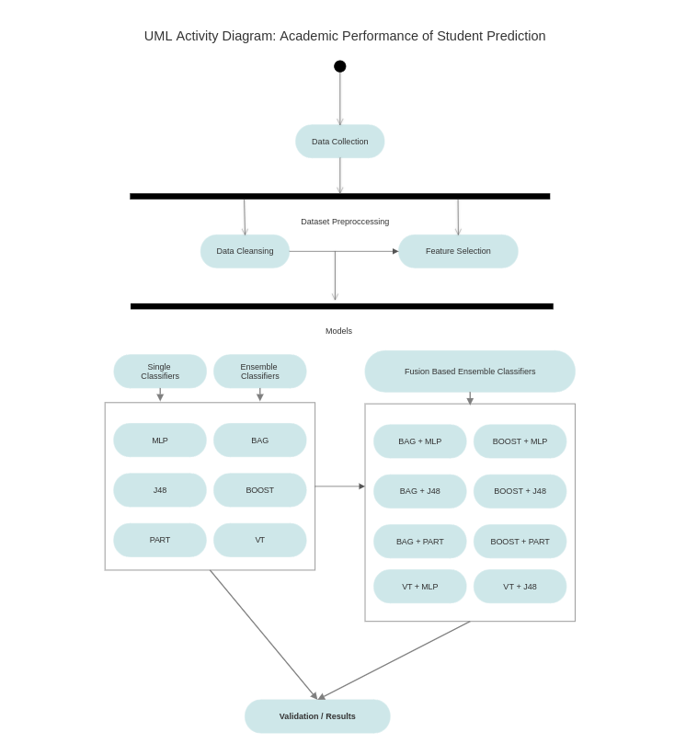

| Operating System | Windows OS, Linux, and Mac OS (Python must be installed on the selected Operating System used.) |
| --- | --- |
| Front-End Technologies | HTML5, CSS3, JavaScript |
| Server-side Technologies | Python3, Flask, WebSocket, EventEmitter |
| Server | Python3 |
| Back-End Tools | CSV, SQLite, Jupiter Notebook |
|  |  |

**Hardware Requirements**

| Device | Computer (Desktop, Laptop) |
| --- | --- |
| Processor | Intel Core i5 3rd Gen or higher |
| Memory | 4gb ram or higher |
| Server | Python3 |
|  |  |